When old goods are put to bed, charity springs into action
June 25, 2012

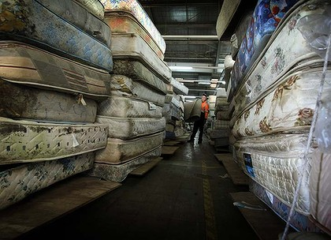

Cushioning the blow of waste management ... Michael Lamb stands among some of the hundreds of mattresses used by Mission Australia in a recycling program. Photo: Sylvia Liber
IF OLD mattresses could talk, we probably wouldn't want to know what they'd reveal.
But a new recycling program is making sure the story of each abandoned mattress at least has a happy ending.
Thousands of tonnes of abandoned bedding, dropped off at landfill sites or left on street corners, are being reused as everything from padding inside punching bags, to garden woodchips, to steel in wind turbines.
Advertisement: Story continues below
The mattress recycling program run by the charity Mission Australia started as a local scheme in a small Wollongong workshop two years ago and has now expanded to an industrial-scale operation, covering metropolitan Sydney and employing 65 staff.
''It began when the local council started putting an exemption on some of the items that could go into landfill - overnight we went from getting one or two illegally-dumped mattresses a month to about 30,'' said Bill Dibley, Mission Australia's social enterprise manager.
''They were everywhere. We started taking the mattresses back to the warehouse, and we had some volunteers, and we started to pull them apart and take them back to the landfill as components,'' Mr Dibley said. ''But we could see it was going to become an ongoing issue, so we started to think about recycling.''
Every possible scrap of material is now salvaged. The statistics of the ''Soft Landing'' program are impressive.
Since last July, old bed springs have yielded 141 tonnes of recycled steel; 39 tonnes of timber from bed frames have been turned into woodchips; 36 tonnes of textile wadding and 21 tonnes of foam have been extracted for use as various kinds of padding. Among other things, the group now has a contract with a sporting goods company to provide stuffing for 40,000 punching bags.
All the employees are people who have battled long-term unemployment or other disadvantages that have made finding regular work hard.
''The people we employ are the people whose CVs don't usually ever come to the top of the pile, but we have now seen quite a lot go on to apprenticeships or other employment,'' Mr Dibley said.
The charity has partnered with waste management company SITA to establish collection points at SITA-operated rubbish and recycling sites. Mission Australia teams also offer free pick ups for used mattresses in some areas of Sydney and Wollongong.
But an estimated 1.25 million old mattresses are still dumped or buried in landfill each year, and the group is keen to get its hands on as many of them as possible.
Read more: http://www.smh.com.au/nsw/when-old-goods-are-put-to-bed-charity-springs-into-action-20120624-20whk.html#ixzz1yqxB48XG

